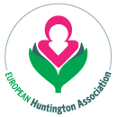

Programme for the EHA Business Meeting

September 15th

17.00 hrs

- Welcome by EHA President Bea de Schepper
- Presentation of Annual Report
- Update on the Financial Status
- Annual report from member associations
- Election of the Board
- Presentation of the EHA project ‘Stronger Together’
- AOB

20.00 hrs – Dinner at the World Forum

- The dinner will be informal and we want all of you to join us so we can get to know each other better.

