We are so happy that you will join us the 18th of August! Here is a guide on how to register. You have to go through three steps: register, pay and confirm your participation. We are looking forward to seeing you in Belgium in August!

How to register

- Go to http://www.proximuscyclingchallenge.be/
- Click on:

- Scroll down to “Zaterdag 18.08.2018 Géants des Ardennes”
- Click on:
- Scroll down and click on:

- At this page you can chose language by clicking at the flags in the lower left corner.

- Select your group by clicking “Join a group” (you can only chose one: 80km / 112km / 153 km)
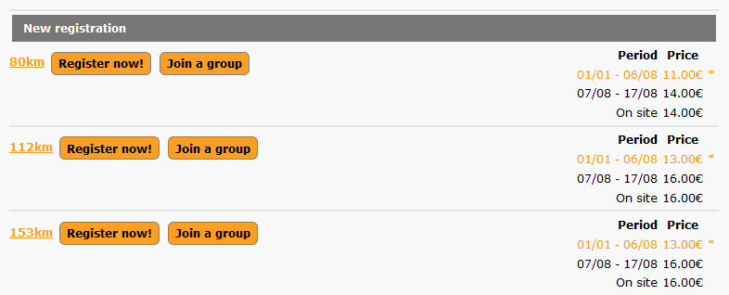

- Fill in the code HDON15559 for our group, HD on the BIKE, and click “next>”
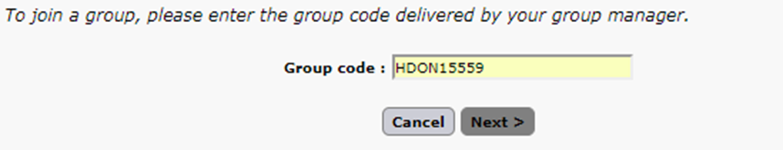

- Select: “I don't have a Like2Sport account (…)” and click “next>”
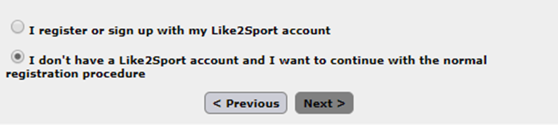

- Fill in your personal info on the next page. Click “next”

- On the confirmation page you will see that you don't pay directly to the organizers but to our group manager – which is Jeroen De Schepper (read more about payment below)

- Click “finish”

How to pay

Please make you payment to Jeroen De Schepper
- 80 km: 11 € + 5* €
- 112 km: 13€ + 5€
- 153 km: 13€ + 5€

Bank account (IBAN): BE05001518416475
BIC: GEBABEBB
Message: 'Your full name' - HD on the Bike

*5€ is only a guarantee. You will either get it back at the end of the race or get a T-shirt

Confirmation

Send an email to both jeroendeschepper@gmail.com and astri@eurohuntington.org.
Write who you are, that you have registered and made the payment.

Congratulations! You are ready for an amazing journey

